**Eo Ipso**

The tool supports six different internal reconstruction methods, which are described in detail in Bischoff (2022). For more detailed methodological questions, see chapters 8-12.

**1. Paradigmatic Approach**

As input file for the paradigmatic method either a self-created file can be used or, alternatively, the German Wiktionary file can be read in. The self-created file needs the following structure:

Lemma noun/verb/adjective all allomorphs (separated by tabs)

An example file is WiktionaryEntriesIPA.txt that can be found in the directory *supplementData*. If Wiktionary is to be read in, a folder *data/rawData/Wiktionary* must be created, in which the file *dewiktionary-latest-pages-articles.xml* must be stored. This xml can also be found in the directory *supplementData*.

*Example*

The following example uses the function "Use IPA Entries from Wiktionary" for German data, as it was done in Bischoff (2022).

Ein Bild, das Text enthält.

By clicking on the menu item *Paradigmatic* the paradigmatic method will be selected. As input file *WiktionaryEntriesIPA.txt* can be dragged into the Drag&Drop field.

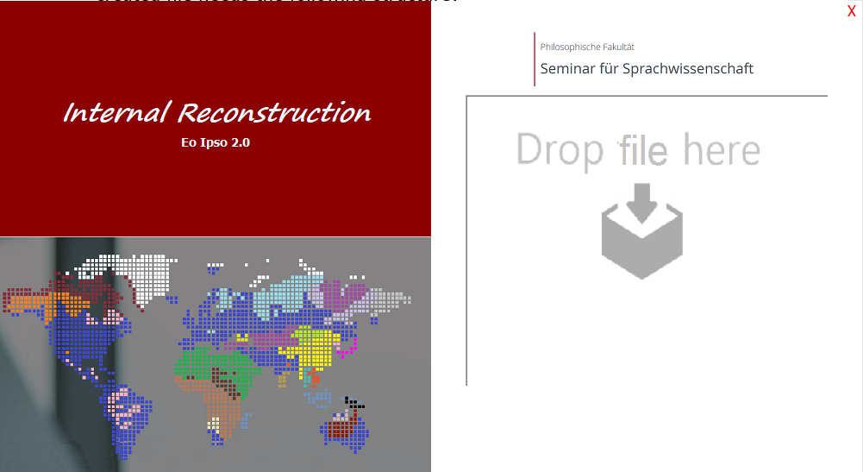

After that step, an analysis will be performed, and the result will be displayed. Incorrect information can be corrected by the user. It is important that the language is added here.

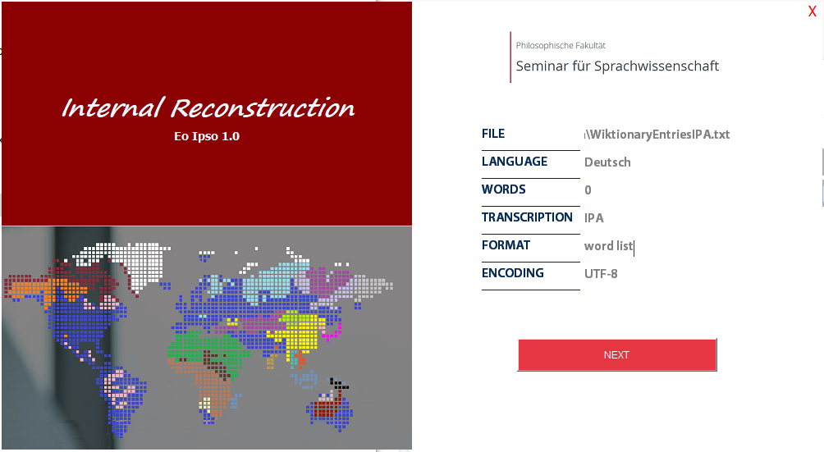

In the last frame, three specifications can be selected:

*Max. iterations*

Maximum number of iterations or phonetic laws to be reconstructed.

*Use Wiktionary instead of the file*

uses the lemmas from the German Wiktionary instead of the specified file.

*Use IPA from Wiktionary instead of the file*

uses instead of the given file the lemmas with IPA transcriptions from the German Wiktionary.

Ein Bild, das Text enthält.

**2. Derivational Approach**

As input file for the derivational method either a self-created file can be used, or the German Wiktionary file can be read in. The self-created file needs the structure:

Lemma noun/verb/adjective all allomorphs (separated by tabs)

An example file is *WiktionaryDerivativesIPA.txt* from the folder *supplementedData*. If Wiktionary is to be read in, a folder *data/rawData/Wiktionary* must be created, in which the file *dewiktionary-latest-pages-articles.xml* must be placed. This xml can also be found in the *supplementData* folder.

The procedure is the same as for the paradigmatic method (see *Example*).

**3. Semantic Approach**

The input file for the semantic approach needs the following structure:

Lemma 'meaning'

*Example*

An example file is LIV.txt, which contains Proto-Indo-European verbs and was also used in Bischoff (2022).

Ein Bild, das Text enthält.

By clicking on the menu item *Semantic* the semantic approach will be applied. The file *LIV.txt* can be dragged into the Drag&Drop field. In the next step, the result of the automatic analysis will be displayed. Incorrect information can be corrected by the user. In this example, *Proto-Indo-European* was specified as language in order to be able to use the manual assignments.

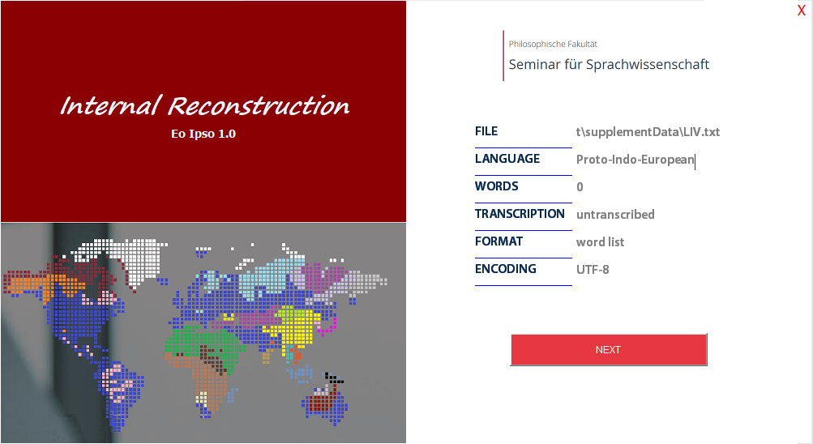

In the last frame, the maximal number of iterations of the Needleman-Wunsch algorithm can be choosen. For Fig. 9.8 (Bischoff 2022), one iteration was performed; for Fig. 9.5, the sound *kw* in *LIV.txt* was replaced by *q* to avoid the digraph.

**4. Phonotactic Approach**

Suitable input files for the phonotactic approach are word lists, morpheme lists, and corpora. As example files, you can find *DeutschKorpusWiktionaryIPA.txt* (German) and *IndogermanischLIVohneRKH.txt* (Proto-Indo-European) in the folder *supplementedData*.

*Example*

Ein Bild, das Text enthält.

By clicking on the menu item *Phonotactic* the phonotactic approach will be applied. The file *DeutschKorpusWiktionaryIPA.txt* can be dragged into the Drag&Drop field. In the next step, the result of the automatic analysis will be displayed. Incorrect information can be corrected by the user.

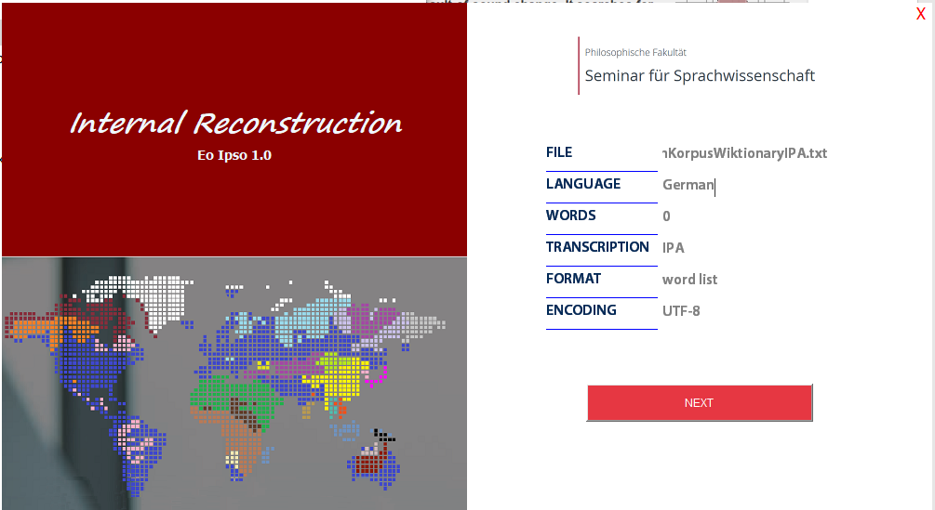

By clicking on the button *NEXT*, the final frame is shown. It contains three different specifications:

*Max. iterations*

Maximum number of iterations or phonetic laws/phonotagms to be reconstructed.

*Complementary Sounds*

method how to choose the complementary sound for a specific phonotagm. For more details, see Bischoff (2022:171–178).

*Threshold*

only phonotagms with an *featSel* value more than x are considered relevant (see Bischoff 2022:171).

*Number Languages*

number of similar languages for the sub-typological approach (see Bischoff 2022:174-176).

Ein Bild, das Text enthält.

**5. Distinctive Approach**

For the distinctive approach, word and morpheme lists are possible as input files. An example file for German is *CELEXMorphemeIPA.txt* (see folder *supplementData*).

*Example*

Ein Bild, das Text enthält.

After clicking on the menu item *Distinctive*,the phonotactic approach, the file *CELEXMorphemeIPA.txt* can be dragged into the Drag&Drop field. In the next step, the result of the automatic analysis will be displayed. Incorrect information can be corrected by the user and the language must be entered.

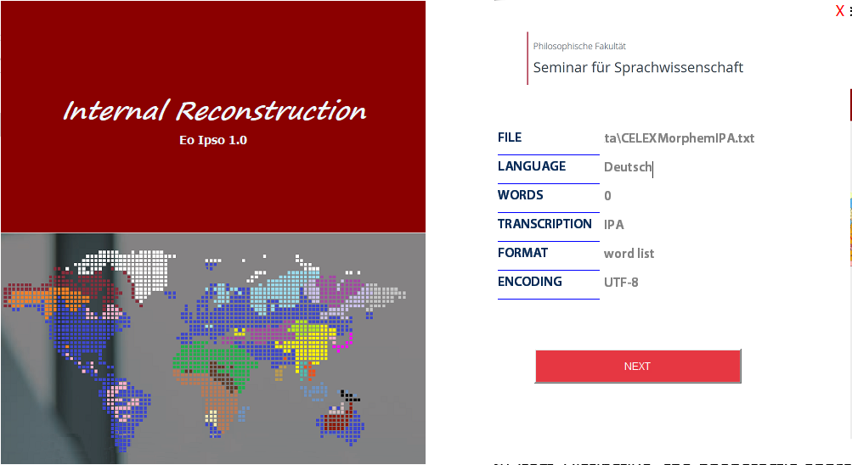

In the last frame, different specifications can be selected:

*Max. iterations*

Maximum number of sound changes to be reconstructed.

*Exclude all consonants*

only use vowels

*Exclude all vowels*

only use consonants

*Threshold*

only Jaccard indices more than x are considered relevant (see Bischoff 2022:195)

*Exclude sounds*

exclude some sounds (separated by commas)

*Typological Sound Correspondences*

uses the empirical sound correspondences from Brown et al. (2013) to find sound pairs

*Using own clusters*

uses own clusters instead of the *EoIpso* clustering. Up to five clusters are possible. The sounds of a cluster should be separated by commas.

*Weights (g1)*

weight of the measure 𝑐𝑜𝑛𝐷𝑖𝑓𝑓(𝑠1, 𝑠2) (first summand of Ja𝑐𝑐𝐶𝑜𝑠(𝑠1, 𝑠2), see Bischoff 2022:194–195).

*Weights (g2)*

weight of cosine similarity (second summand of Ja𝑐𝑐𝐶𝑜𝑠(𝑠1, 𝑠2), see Bischoff 2022:194–195).

The Fig. 11.8 in Bischoff (2022) uses more specific sound classes than those of *EoIpso*. Similar result for German is achievable with the file *CELEXMorphemeIPA.txt*, the typological method, and following inputs:

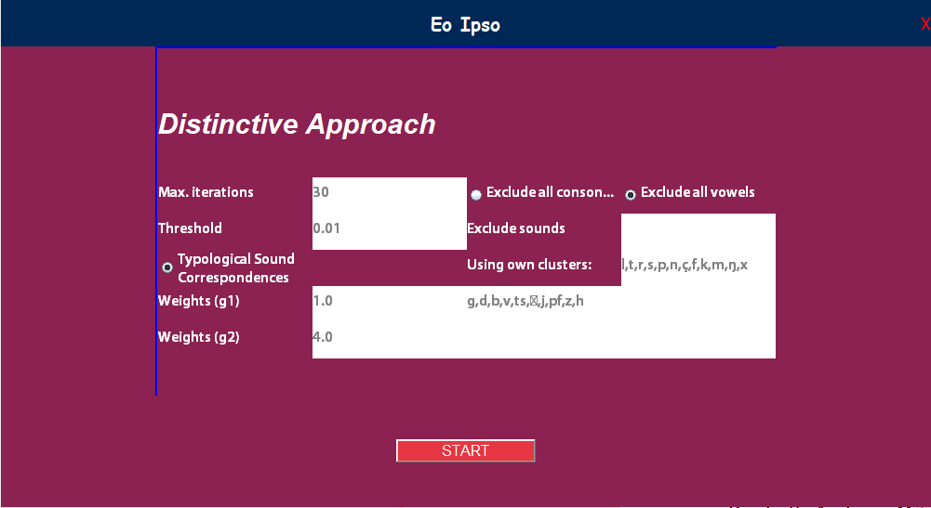

In the case of vowels, the typological method is not useful due to lack of data.The clusters "ɐ,ə", "ɪ,ʏ,ʊ,a,ɔ,ɛ", and "i:,u:,y:,o:,e:,ø:,ɛ:,a:,œ,ɔʏ,aɪ,aʊ" used were.

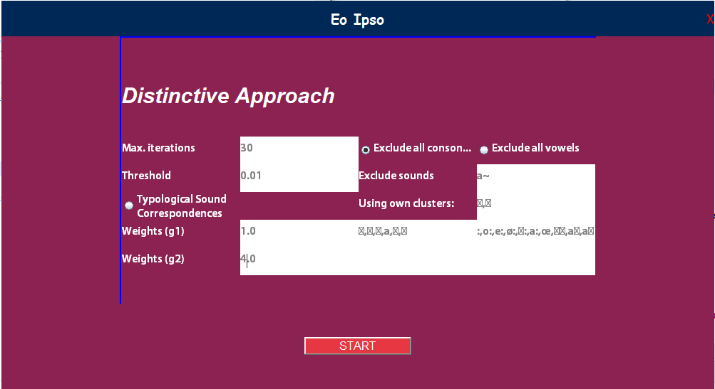

For the Proto-Indo-European, the file *IndogermanischLIVohneRKH.txt* was used. This file excludes words containing placeholders (e.g., *H* for any laryngeal). Two clusters were used: "ḱʰ, tʰ, pʰ" and "bʰ, g, dʰ, h2, gᵂ, h1, ģʰ, h3, y, d, l, k, n, r, gʰ, w, s, ģ, m, ḱ, p, kᵂ, t, gᵂʰ, b". The vowels *a* and *e* were excluded, the mode was "non-typological" and the weights were set to 2.0 and 0.5. In a second trial, the vowels and the aspirated sounds ḱʰ, tʰ, and pʰ were excluded. The used clusters were "l, r, n, y, w", "b, gᵂʰ, gʰ", "dʰ, d, k, s, m, ḱ, kᵂ, t, h1, h2, h3", "g, bʰ, gᵂ, ģʰ, ģ", and "p".

**6. Gap Approach**

As input file for the gap method, a file is necessary that contains all sounds of the language in question and their distinctive features. Thus, the file needs the following structure:

No. sound distinctive features of the sound (separated by tabulators)

Example files are *Merkmalsphonetik_Deutsch.txt* for German and *Merkmalsphonetik_Indogermanisch.txt* for Proto-Indo-European.

Ein Bild, das Text enthält.

By clicking on the menu item *Gap Method* the phonotactic approach will be applied. The file *Merkmalsphonetik_Deutsch.txt* can be dragged into the Drag&Drop field. In the next step, the result of the automatic analysis will be displayed. Incorrect information can be corrected by the user.

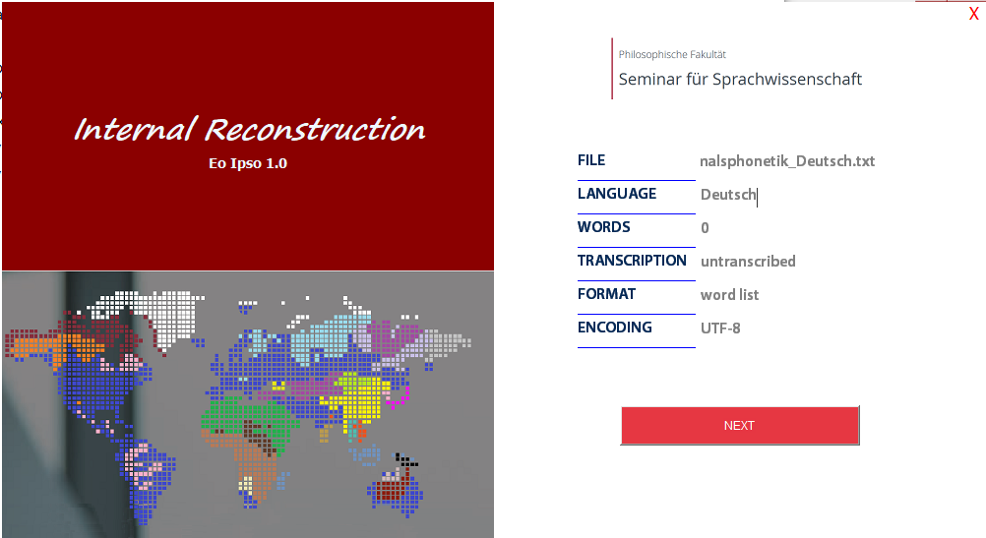

In the last frame, three different specifications can be selected:

*Max. iterations*

Maximum number of sound changes to be reconstructed.

*Threshold*

only sound correspondences from Brown et al. (2013) are considered with a *typo* value more than x (see Bischoff 2022:205).

*Typological Sound Correspondences*

only sound correspondences from Brown et al. (2013) are considered.

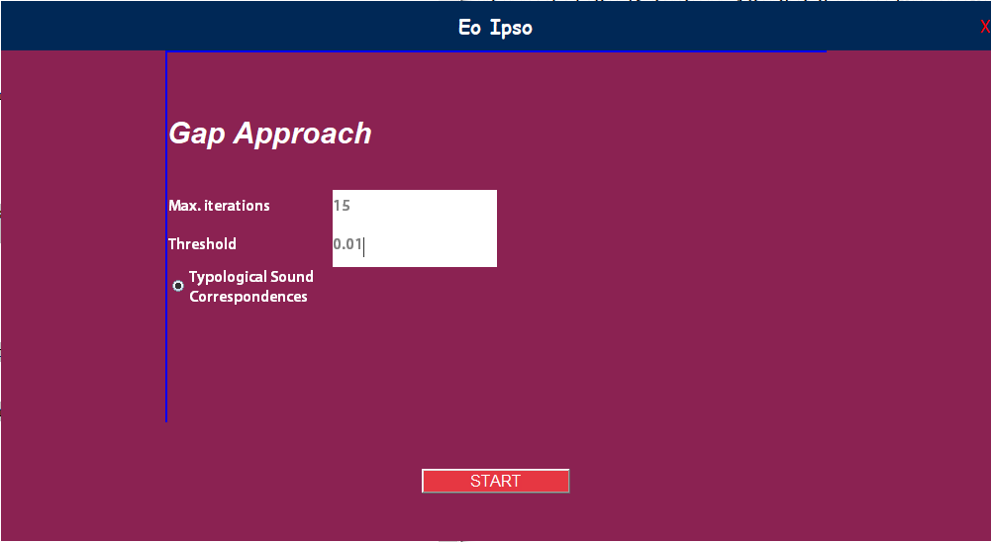

**Bibliography**

Bischoff, Andreas M. (2022): Eo Ipso – Automated Internal Reconstruction. Univ. of Tübingen.

Brown, Cecil / Holman, Eric & Wichmann, Søren (2013): Sound Correspondences in the World’s Languages. In: Language 89(1). pp. 4–29.